TEAM PROJECT REPORT

Understanding the Spatiotemporal Variability of Air Pollution (PM_{2.5} & BC) in Microenvironments

Submitted To

The RET Site
For
“Challenge-Based Learning and Engineering Design Process Enhanced Research Experiences for Middle and High School In-Service Teachers”

Sponsored By
The National Science Foundation
Grant ID No.: EEC-1404766

College of Engineering and Applied Science
University Of Cincinnati, Cincinnati, Ohio

Prepared By

Molly Hamilton, 10-12th Grade Math, The School for Creative and Performing Arts, Cincinnati, OH
Kat Roedig, 11-12th Grade Science, The Summit Country Day School, Cincinnati, OH

Approved By

___________________________________
Dr. Sivaraman Balachandran, PhD, PE
Department of Chemical and Environmental Engineering
College of Engineering and Applied Science
University of Cincinnati
Reporting Period: June 12 – July 27, 2017
Understanding the Spatiotemporal Variability of Air Pollution (PM_{2.5} & BC) in Microenvironments
Molly Hamilton, 10-12th Grade Math, The School for Creative and Performing Arts, Cincinnati, OH
Kat Roedig, 11-12th Grade Science, The Summit Country Day School, Cincinnati, OH
Abstract
PM_{2.5} has been identified to have significant association with human health. Understanding the personal exposure to PM_{2.5} and black carbon (BC) using different means of transportation could help to prevent negative health effects of air pollution in Cincinnati. The focus of our research was studying air and noise pollution in specific microenvironments. Portable air pollution monitors were co-located with Southwest Ohio Air Quality Agency (SWOAQA) continuous monitors in order to confirm the quality of gathered data as well as to measure air pollution and noise at a near highway location. Portable monitors were used to measure the ambient air pollution concentrations in one medium-income neighborhood (Clifton) and one low-income neighborhood (Camp Washington). It was expected that the pollution concentration in Camp Washington is higher than Clifton due to its proximity to industry, the highway, and a railyard. Further, these monitors were used to evaluate the personal exposure to air pollution using various modes of transportation in the mentioned locations. The data was processed and analyzed using standard statistical methods. This work lays the foundation for future work to better understand spatial variability of air pollution at fine spatial scales. These results will be disseminated through presentations, discussions, and units implemented in a school setting.

Key Words
Particulate matter, black carbon, air pollution, noise pollution, sound, microenvironments
1. INTRODUCTION
The six criteria air pollutants as defined by the Environmental Protection Agency (EPA) that are required by the Clean Air Act to be regulated by National Ambient Air Quality Standards (NAAQS) include: ground-level ozone, particulate matter (PM), carbon monoxide, lead, sulfur dioxide, and nitrogen dioxide (“Criteria Air Pollutants,” 2017). PM is regulated under the NAAQS based on its size (Cheung et al., 2011). Particulate matter can be identified as coarse (2.5-10 micrometers in diameter), fine (≤ 2.5 micrometers in diameter) or ultrafine (≤ 0.1 micrometers in diameter). This research study focuses more specifically on fine particulate matter (PM_{2.5}) and one of its important constituents, black carbon (BC). PM_{2.5} is small enough to pass through respiratory defense mechanisms such as cilia or mucous membranes, and can infiltrate deep into the alveoli within the lungs where oxygen gas transport takes place (Harrison and Yin, 2000). It is there that it can enter the bloodstream which is what greatly impacts one’s health (Harrison and Yin, 2000). PM_{2.5} is made up of particles emitted by vehicles from combustion and from the burning of coal, oil, and biomass (Laden et al., 2000). The components of PM_{2.5} include sulfate, nitrate, ammonium, metals, and organic and elemental carbon. Elemental carbon (EC), also known as black carbon (BC) if measured optically, is an ultrafine particle that comes from various sources, but the primary interest in this study are vehicular sources, especially diesel vehicles. BC is not only a health concern but also has a positive global warming potential (Bond et al., 2013). Because this particle is so small, it is easier to inhale and has a greater surface area to mass ratio that can build up over time and penetrate deeper into the lungs causing inflammation in the area between the alveoli and the bloodstream (Harrison and Yin, 2000). This inflammation can encourage the production of clotting factors in the blood which is what links high exposure to air pollutants to the onset of ischemic heart disease (Harrison and Yin, 2000).
The City of Cincinnati, comprised of 53 distinct neighborhoods, is known for its unique topography of various hills and valleys throughout the city. Understanding the terrain and topography along with local meteorology is essential to understanding air pollution patterns. The location of the near roadway (NR) site, maintained by the Southwest Ohio Air Quality Agency, is an important location to study air pollution in Cincinnati because it is situated between a major roadway (I-75) and a major railyard (CSX) in the historically industrial neighborhood of Camp Washington. Fig. 1 shows that the life expectancy in Camp Washington is approximately 68 years but in Clifton, which is located next to Camp Washington, the life expectancy is much greater at approximately 80 years. To better understand air pollution’s role in a neighborhood such as Camp Washington, our study focuses on the collecting of air and noise pollution data at the Near Roadway site (NR site). Our study also gathers data from microenvironments, including commutes to and from University of Cincinnati’s (UC) campus/NR site and Northern Kentucky, Fairfield, Blue Ash, Colerain and West Chester. Further, we collected data by foot and shuttle in Clifton and by foot in Camp Washington.

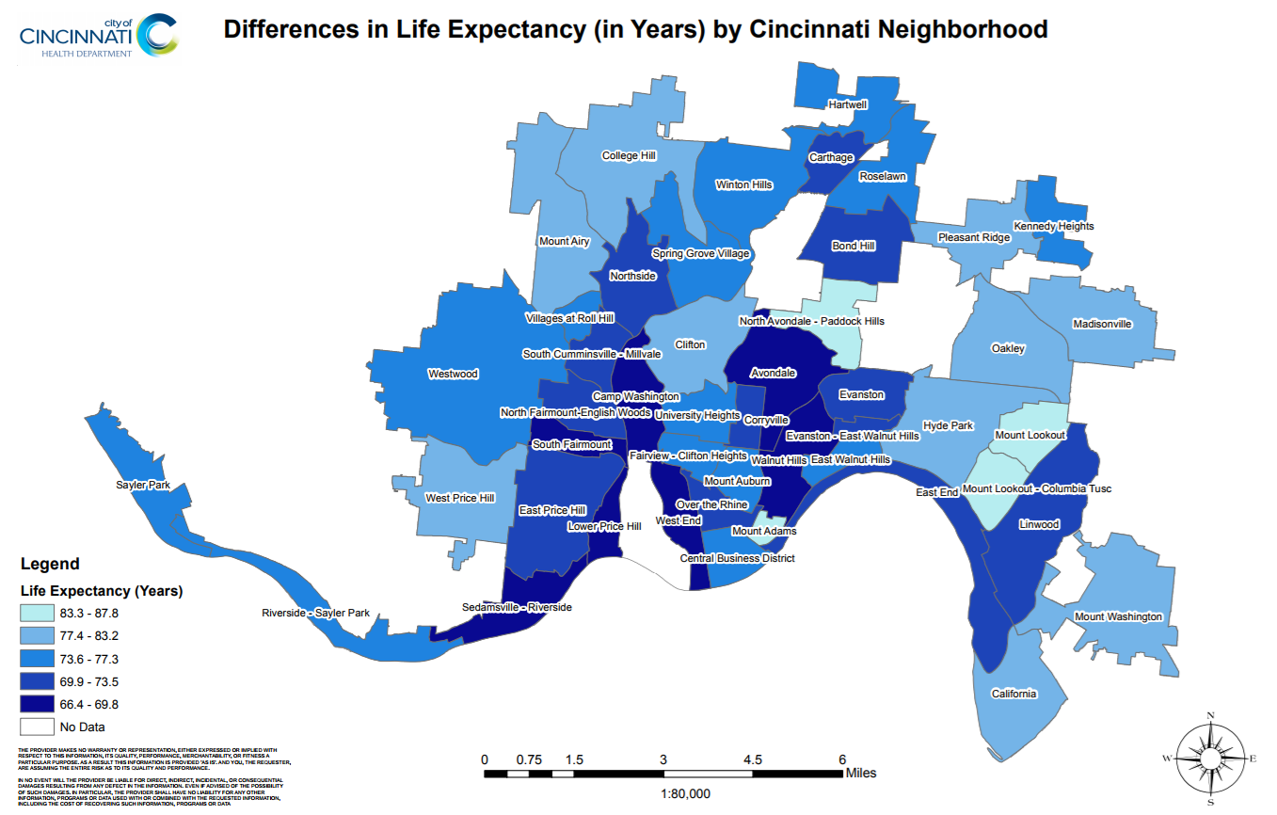
Figure 1. Life Expectancies in Years by Cincinnati Neighborhood (“Neighborhood Life Expectancy Data,” n.d.)

2. LITERATURE REVIEW
Studying the effects air pollution on health is complicated by the mix of interrelated, dependent and independent variables that impact health. As a result, a number of studies have looked at air pollution along with other factors, including sound, traffic, and modes of transportation, while also having to consider weather, health of the participants, intake dose, and physical activity, to name a few. Along with monitoring air pollutants, the Clean Air Act also specifies limits for noise pollution. Noise pollution is any annoying or distressing sound that interferes with sleep, daily activities or negatively affects one’s quality of life (“Clean Air Act Title IV - Noise Pollution,” 2017). Research studies have shown that there are direct links between noise pollution and human health. In addition, research has also shown that air pollution and noise pollution have potential synergistic effects that can lead to diminished health and poor quality of life (Beelen, R., Hoek, G., Houthuijs, D., Brandt, P. A. V. D., Goldbohm, R. A., Fischer, P., Schouten, L. J., Armstrong, B., and Brunekreef, B, 2008).
Hoek et al. (2002) used data from a study in the Netherlands to look for an association between traffic-related air pollution and mortality. They concluded that there is an association between cardiopulmonary mortality and living near a major road. As a follow-up to that, a study was conducted using the same data from the Netherlands study to look at the association of air pollution and noise with cardiovascular mortality (2008). Beelen et al. (2008) investigated the associations between long-term exposure to air pollution and noise and cardiovascular causes of death (Beelen, R., Hoek, G., Houthuijs, D., Brandt, P. A. V. D., Goldbohm, R. A., Fischer, P., Schouten, L. J., Armstrong, B., and Brunekreef, B, 2008). They found that there is an association between traffic intensity, background black smoke and cardiovascular deaths, but not with noise.
Kheirbek et al. (2014) studied the variations of air and noise pollution along busy roadways in New York City. They concluded that the highest levels of noise were during weekday, daytime hours and that most noise levels exceeded the recommended guidelines set by the World Health Organization and the Environmental Protection Agency. In addition, they found that sound levels followed a diurnal pattern; meaning the highest sound levels occurred in the late-morning and mid-day hours and were lowest during overnight hours. In the end, they noted that there was a correlation between average noise levels and air pollutants (NO, NO₂, and black carbon) which can be “helpful in creating risk assessment models for health effects research and ultimately strategies that mitigate exposures to traffic-related chemical and nonchemical stressors” (Kheirbek et al., 2014).
From 2003 to 2010, Fecht et al. (2016) evaluated the road traffic noise and air pollution in London by looking at “exposure bands, specific distance bands from heavily traffic roads and deprivation bands.” One of the most surprising conclusions was that while road traffic is the dominant source of air pollution in London, there was very little change to the noise and air pollution over the course of the research, even though many policy changes were made to reduce emissions. Correlations between the variables depended greatly on the area that was used, with correlations between noise and PM_{2.5} increasing as the area decreased. They concluded that noise and air pollution were moderately correlated and that future studies should consider spatial unit of analysis.
Modes of transportation, physical activity, transportation time and speeds were studied along three routes in Bogota, Columbia, by Morales Betancourt et al. in 2016. Buses had the highest exposure concentration and dose inhaled per unit time when compared to taxis, cars, motorcycles, walking and cycling. Pedestrian had the highest average dose per unit length due to slower travel and increased breathing rate. Cars had the lowest dose.
There is evidence from a cohort study that ”long-term exposures to PM2.5 and ozone were associated with an increased risk of death, even at concentrations below the current annual NAAQS for PM2.5” (Di et al., 2017). Higher PM concentrations are in the eastern and southeastern United States, while higher ozone concentrations are in California and the western mountain ranges. They also revealed that black, Asian, and Hispanic men “had a higher estimated risk of death” (up to three times higher) “from any cause in association with PM2.5 exposure than the general population” (Di et al., 2017). This stronger association between PM_{2.5} and mortality at the lower concentrations suggests that the NAAQS standards may have to be reevaluated.
3. GOALS AND OBJECTIVES
Since pollution varies spatially, we want to monitor various areas through the use of lower-cost, portable monitors to gather more data on air pollutant (PM_{2.5} and BC) and sound levels. The overarching goal of this research study is to understand air pollutant concentrations (PM_{2.5} and BC) in different microenvironments as well as to evaluate the lower-cost, portable monitors. Some objectives include:
- To understand the spatiotemporal variability of air pollution (specifically PM_{2.5} and black carbon) in microenvironments
- To understand environmental data analysis
- To compare low-cost with high-cost sensors

4. RESEARCH STUDY DETAILS
The focus of our research was to look at air and noise pollution in specific microenvironments. The specific microenvironments are the near roadway site, in-vehicle during work commutes, in-vehicle during UC Shuttle routes, and ambient concentrations in Camp Washington and the UC/Clifton area. We compared high and low cost instruments, as well as BC and sound, at a NR site along I-75. We also looked at three different commute routes in three different vehicles. Different variables were being tested in these commutes, including: car year, windows up/down, air conditioning on/off, highway/backroads. Additionally, we looked at shuttle routes at the University of Cincinnati and did walking studies along the shuttle bus route on UC’s campus and in Camp Washington. To see how Camp Washington compares to the Clifton area, we looked at the EC/PM_{2.5} ratio at the Taft site, which is located in Clifton, and compared that with the BC/PM_{2.5} ratio at the NR site, which is located in Camp Washington.
4.1 Instruments Used
The instruments used in this research study include two DustTrak II Aerosol Monitors 8530 (DustTrak), four microAeth® AE51 (AE51) monitors, and two Extech 407760: USB Sound Level Datalogger. The DustTrak monitor is a “light-scattering laser photometer that gives real-time aerosol mass concentration readings” (“DustTrak II Aerosol Monitor 8530,” n.d.) that is used to measure various particulate matter sizes. For this study PM_{2.5} concentrations are being measured. The microAeth AE51 monitor measures the “rate of change in absorption of transmitted light due to continuous collection of aerosol deposit on the filter” (“AethLabs,” n.d.) to give us readings for black carbon concentrations in the air. The mass of both PM_{2.5} and BC are measured in µg/m³. The Extech 407760: USB Sound Level Datalogger was used to record real-time sound data in decibels. The use of these monitors gives insight into the composition of the air and the level of sound within our microenvironments that can help us understand more about the health risks associated with air and noise pollution. The phone applications, ‘Geo Tracker’ (for Android) and ‘Mobile Logger’ (for iPhone) were used to collect GPS data for commutes and walking studies.
4.2 Compare DustTrak and AE-51 to Regulatory Instruments
4.2.1 Thermo SHARP 5030i
The near roadway site uses a Thermo Synchronized Hybrid Ambient Real-time Particulate (SHARP) 5030i to collect PM_{2.5} data. It “is a hybrid nephelometric/radiometric particulate mass monitor” that “measures the mass concentration of ambient PM₁₀, PM_{2.5}, and PM_{1.0}” (Thermo Fisher Scientific, 2011). It uses light scattering to deposit mass onto a filter and measures the mass through beta attenuation.
4.2.2 SWOAQA Aethalometer
The near roadway site uses a professional grade Aethalometer to collect BC data.
4.2.3 Data Collection
Data was collected from 17:40:00 on 06/30/17 to 17:25:00 on 07/10/17, at the NR site in Camp Washington at 3428 Colerain Avenue in Cincinnati, Ohio. SHARP data was provided by SWOAQA. DustTrak data was collected by Kat Roedig and Molly Hamilton.
4.3 Commute Studies
Data was collected on weekday commutes during morning and afternoon rush hour to and from the University of Cincinnati and/or NR site from 06/26/17 - 07/14/17. The commutes were conducted from various areas in different settings. GPS, PM_{2.5}, and BC data were collected and displayed on Google Maps for commutes to show where concentrations were highest and lowest along each route.
4.3.1 Kat’s Commutes
Kat commuted to UC/NR site from Fairfield, Ohio on back roads in her 2015 Subaru Forester with the windows up and the air conditioning on. Kat’s commutes home from UC/NR site were to: Blue Ash, Ohio on backroads and then highways I-75 north and OH-126 east; to Colerain, Ohio on highway I-74/US 27 north; or back to Fairfield, Ohio through the same back roads. Kat’s commute data include averages of 30 second data collections for: PM_{2.5} and BC from the mornings and afternoons on 06/26/17-06/29/17, and the morning of 06/30/17; BC data on the mornings and afternoons on 07/05/17, 07/12/17, and 07/13/17; BC on the mornings of 07/07/17 and 07/10/17; and BC on the afternoon of 07/14/17. Some black carbon commute data was omitted because the values were negative, which could indicate an instrument error or show that there was a very low concentration of BC present in the microenvironment.
4.3.2 Molly’s Commutes
Molly commuted to and from UC/NR site from West Chester, Ohio on highway I-75 in her 2005 Mini Cooper with the windows up and the air conditioning on. Molly’s commute data include averages of 30 second data collections for: PM_{2.5} and BC from the mornings and afternoons on 07/05/17-07/07/17, 07/10/17-07/13/17; PM_{2.5} and BC from afternoons on 06/30/17 and 07/03/17; PM_{2.5} and BC from mornings on 07/14/17; and PM_{2.5} from the afternoon on 07/14/17.
4.4.3 Dexter’s Commutes
Dexter commuted to and from UC/NR site from Kentucky on back roads then highway I-75 in his 2004 Ford Taurus with the windows down and the air conditioning off. Dexter’s commute data include averages of 10 second data collections for: BC from the mornings and afternoons of: 06/26/17-06/28/17, 07/03/17, 07/05/17, and 07/12/17; BC from mornings on 06/29/17, 07/07/17; BC from afternoons on 06/30/17, 07/11/17, and 07/13/17.
4.4 Shuttle
4.4.1 Data Collection
Shuttle data was collected on UC’s shuttle bus route through campus and neighboring areas in Clifton on several days from 06/20/17 through 07/11/17. PM and BC was collected on 06/20/17, 06/27/17, and 07/03/17 on the Main St/Eden Ave Garage route. Shuttle data for PM and BC was collected on 06/30/17, 07/07/17, and 07/11/17 on the Main St/Eden Ave Garage route and the North route.
4.4.2 Shuttle Routes
The Main St/Eden Ave Garage route started in front of the Engineering Resource Center. The route has stops at Woodside Drive, Campus Green Drive, Scioto, Scioto/W. University Avenue, Kingsgate Conference Center, Eden Ave. Garage - Rear, Eden Ave. Garage - Front, Kingsgate Center. The North route has stops at Woodside Drive, Campus Green Drive, Goodman Avenue, Jefferson Ave. at W. Nixon St., Jefferson Ave. at Ruther Ave., Jefferson Ave. at Brookline Ave., Ludlow Ave. at Telford St., Ludlow Ave. at Whitfield Ave., Whitfield Ave. at Terrace Ave., Whitfield Ave. at Dixmyth Ave., and Dixmyth Ave. at Clifton Ave.
4.5 Walking Studies
Walking studies were conducted on UC’s shuttle bus route and through the Camp Washington neighborhood close to the NR site. GPS, PM_{2.5}, BC, and sound data were collected and displayed on Google Maps for commutes to show where concentrations were highest and lowest along each route.
4.5.1 UC Shuttle Walk
A walking study of UC’s shuttle bus route was conducted on 07/10/17, from 15:14:30-16:34:00 collecting data points for PM_{2.5} and BC every 30 seconds.
4.5.2 Camp Washington Walks
Camp Washington Walks (CW #1K) and (CW#1M): Two separate walking studies of the Camp Washington neighborhood close to the NR site were conducted on 07/12/17, from 14:38:30-15:17:30 collecting data points for PM_{2.5} and BC every 90 seconds (CW#1K) and 30 seconds (CW#1M). CW#1M also had sound data.
Camp Washington Walk #2: Another walking study was conducted on 07/14/17, from 14:16:30-14:59:00 collecting data points for PM_{2.5} and BC every 30 seconds. BC data was omitted from this study because the values were negative, indicating instrument error.
Camp Washington Walk #3: Another walking study was conducted on 07/17/17, from 16:06:30-17:00:00 collecting data points for PM_{2.5}, BC and sound every 30 seconds. BC data was omitted from this study because the values were negative, indicating instrument error.
4.6 Black Carbon versus Sound
4.6.1 Data Collection
Black Carbon and sound data was collected at the NR site from 07/14/17 at 15:25:00 to 07/15/17 at 17:45:00, from 07/15/17 at 21:10:00 to 07/16/17 at 13:45:00, and from 07/16/17 at 16:00:00 to 07/17/17 at 13:05:00. BC was collected every five minutes. Sound data was collected every second and averaged to five minutes. Breaks in the collection times occurred when the life of the battery on the sound data logger expired. A new battery was installed and the sound data logger was restarted.
4.6.2 Average Calculations
The five minute averages were calculated by taking the antilog of the sound ($10^{(dB/10)}$). Then five minute averages were calculated and converted back to decibels ($10*log(5 minute average)$).
4.7 BC/PM_{2.5} Ratio
4.7.1 NR Site
Data was gathered from the NR site from: 06/30/17 17:40-07/10/17 17:20; and 07/14/17 15:25-07/17/17 17:00 to calculate an approximate BC/PM_{2.5} ratio.
4.7.2 Taft Site
Data was gathered from the Taft site from: 01/01/2008-05/30/2015 to calculate an approximate EC/PM_{2.5} ratio. The Taft site does not measure BC, but measures EC, which is also known as BC.
5. RESEARCH RESULTS
5.1 Compare DustTrak and AE-51 to Regulatory Instruments
Data was collected on the DustTrak and AE-51 for approximately 240 hours. When we applied the correction factor to the DustTrak data, the average hourly concentration of PM_{2.5} is 16.5 µg/m³, with a standard deviation of 13.4 µg/m³. The average hourly concentration of PM_{2.5} based on SWOAQA SHARP instrument data is 12.3 µg/m³ with a standard deviation of 9.3 µg/m³. The average hourly BC concentration on the AE-51 was 1.8 µg/m³ with a standard deviation of 1.1 µg/m³. The average hourly BC concentration based on SWOAQA Aethalometer data is 1.7 µg/m³ with a standard deviation of 1.2 µg/m³.
5.1.1 SHARP versus DustTrak
A linear correlation calculated the coefficient of determination of 0.83 (Fig. 2). The average SHARP to DustTrak ratio gives a correction factor of 0.87. The linear equation is $y=0.66(±0.006)x+2.1(±0.14)$.

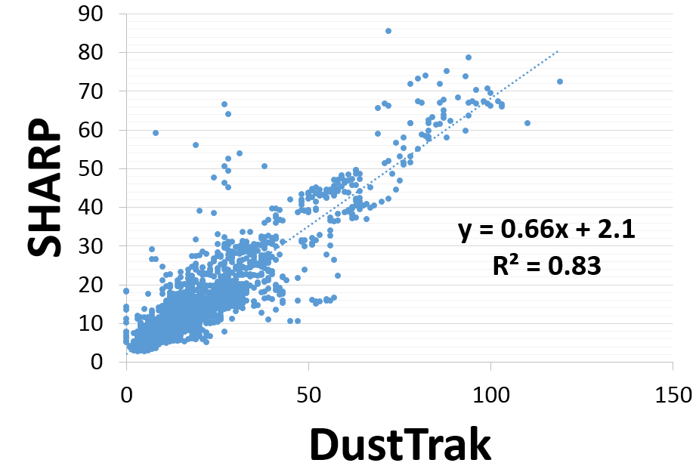
Figure 2. SHARP versus DustTrak at Near Roadway Site
5.1.2 AE51 versus Aethalometer
A linear correlation calculated the coefficient of determination of 0.68 (Fig. 25). The linear equation is $y=0.86(±0.039)x+0.22(±0.082)$.
5.1.3 Conditions at the NR Site
Our data shows that the PM_{2.5} and BC concentrations at the NR site are greatly reduced by precipitation. Wind speed and direction also have a significant impact on carrying the PM_{2.5} from the roadway to the monitoring devices (Appendix III: Fig. 26-27).
5.2 Commute Studies
5.2.1 PM_{2.5}
Kat and Molly’s data suggests that there was a higher exposure to PM_{2.5} during the morning commutes versus the afternoon commutes (Fig. 3 & 4).
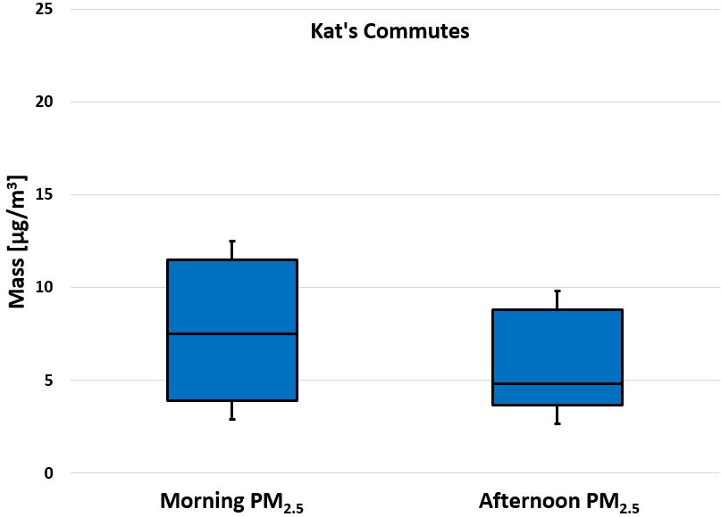
Figure 3. Averages of Kat’s Commutes PM_{2.5}
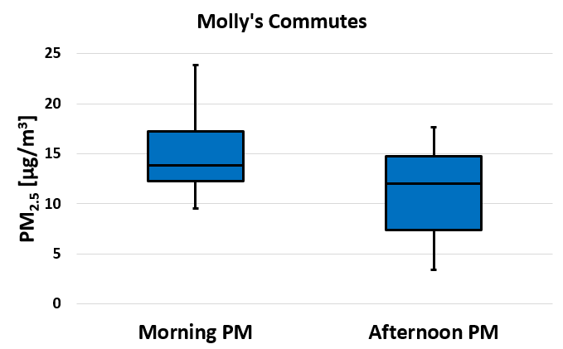
Figure 4. Averages of Molly’s Commutes PM_{2.5}
5.2.2 BC
Kat and Dexter’s data suggests that there was a higher exposure to BC during the afternoon commutes versus the morning commutes (Fig. 5 & 7). Molly’s BC data (Fig. 6) is consistent with her PM_{2.5} data that there was a higher exposure to BC during the morning commutes versus the afternoon commutes.

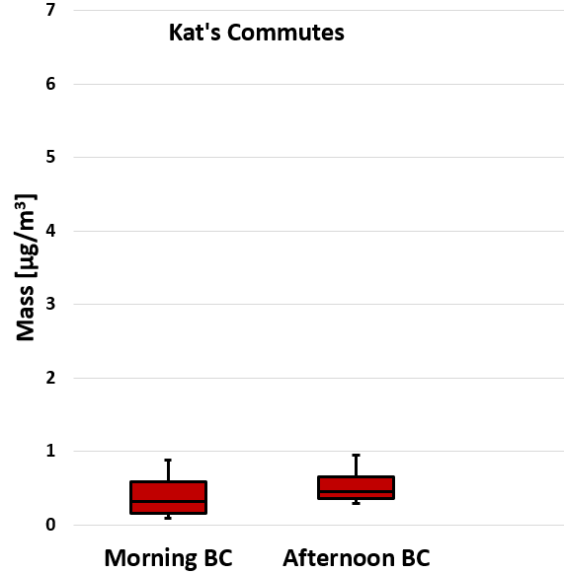
Figure 5. Averages of Kat’s Commutes BC

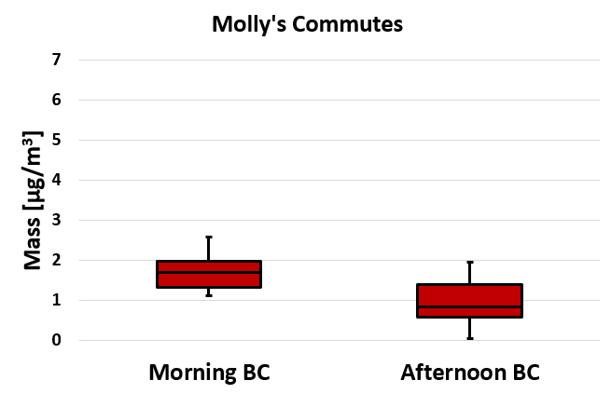
Figure 6. Averages of Molly’s Commutes BC
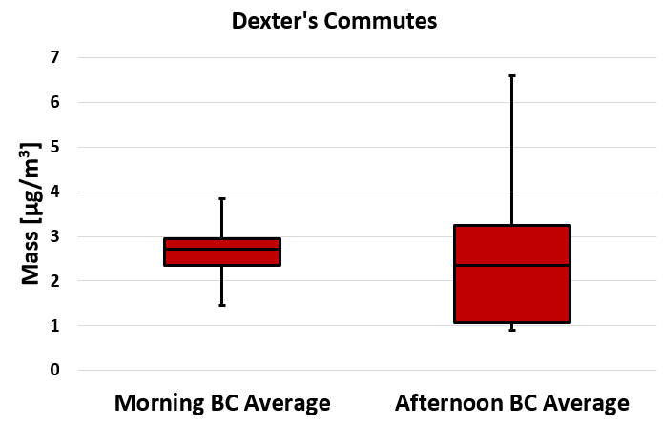
Figure 7. Averages of Dexter’s Commutes BC
5.2.3 Maps of 07/05/17 Morning Commutes BC Concentrations
The map of Kat’s data (Fig. 8) shows that BC concentrations were low along her commute, until she approached UC’s campus where the BC concentrations slightly increase. The map of Molly’s data (Fig. 9) shows that BC concentrations were highest while she was driving south on I-75 near the Lincoln Heights area. The map of Dexter’s data (Fig. 10) shows that BC concentrations were variable along his morning commute. The concentrations were high in the Fort Wright, Park Hills, and bridge areas.

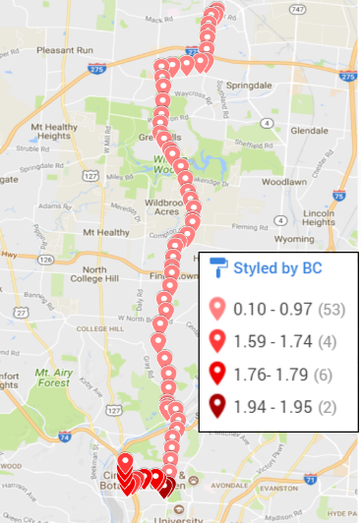
Figure 8. Kat’s Commute 07/05/17

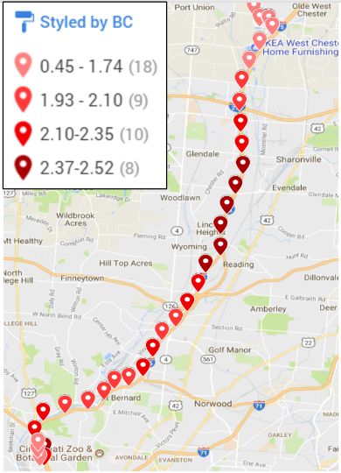
Figure 9. Molly’s Commute 07/05/17

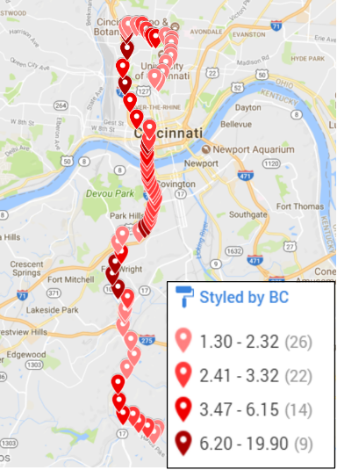
Figure 10. Dexter’s Commute 07/05/17
5.3 Shuttle
5.3.1 Shuttle Results
There was a large amount variability in the data collected on the shuttle runs (Fig. 11). The BC average was much higher on 06/30/17, while there was zero BC on 07/03/17. The PM_{2.5} average was between 15 and 30 µg/m³ on 5 out of the 6 days, while there was 5.6 µg/m³ on 06/20/17. This variability could be due to the different routes taken, weather conditions, topography, time of day, condition of the shuttle bus, or the circulation in the bus. It seemed like the air conditioning was not working in any of the shuttles.

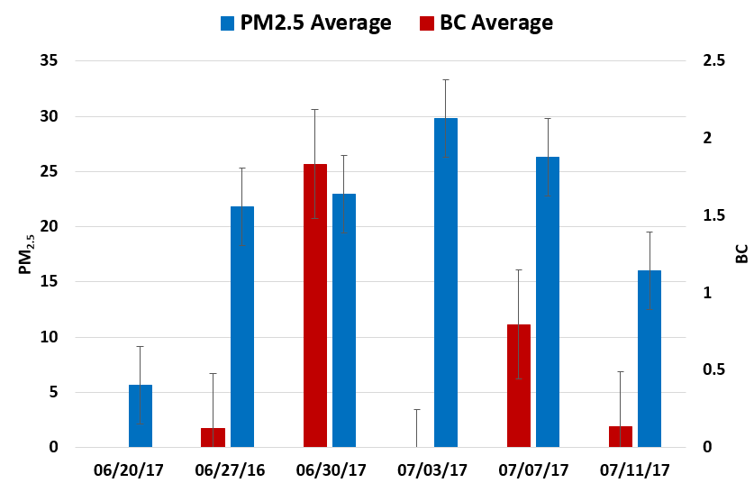Figure 11. Averages of Shuttle routes
5.4 Walking Studies
5.4.1 PM_{2.5}
The data suggests that there was a higher exposure to PM_{2.5} during Camp Washington walks CW#1K and CW #1M, and #2 versus the UC Shuttle Walk. Camp Washington Walk #3 data suggests that there was a lower exposure to PM_{2.5} versus the UC Shuttle Walk (Fig.12).
5.4.2 BC
The data suggests that there was a higher exposure to BC during Camp Washington walks CW#1K and CW#1M versus the UC Shuttle Walk (Fig. 12). BC data was omitted from Camp Washington walks # 2 and # 3 because the values were negative, indicating instrument error.
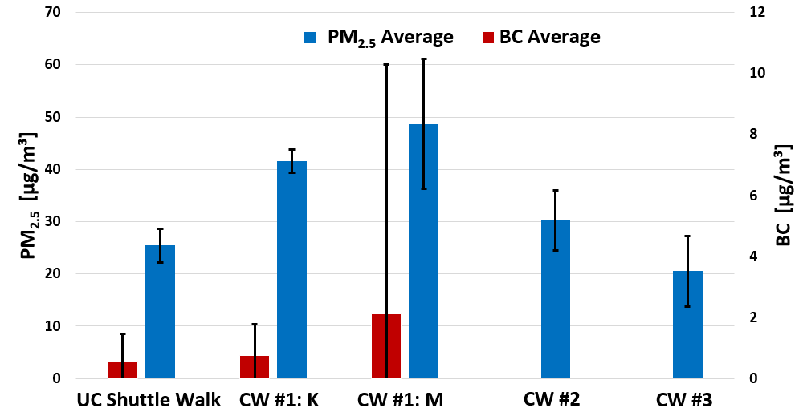
Figure 12. Averages of Walking Studies
5.5 Black Carbon versus Sound
5.5.1 Five-Minute Averages
When sound was averaged every five minutes, a linear correlation calculated the coefficient of determination of 0.0977. The linear equation is $y=0.11(±0.012)x-6.78(±0.94)$. This tells us that there is very little correlation between BC and Sound when averaged every five minutes.

5.5.2 Hour Averages
When sound was averaged every hour, a linear correlation calculated the coefficient of determination of 0.187. The linear equation is $y=0.16(±0.044)x-10.46(±3.31)$. This tells us that there is a mild correlation between BC and Sound when averaged every five minutes.
5.6 BC/PM_{2.5} Ratio
5.6.1 NR Site
Using the data gathered, the ratio of BC/PM_{2.5} is about 11.9%.
5.6.2 Taft Site
Using the data gathered, the ratio of EC/PM_{2.5} is about 5.3%.
6. CONCLUSIONS
There is good correlation between the SHARP PM_{2.5} measurements and the DustTrak PM_{2.5} measurements. The correction factor of approximately 0.87 shows that the DustTrak data is a little too high, especially at higher concentrations (Fig. 13 & 14). Lower cost, portable monitors are a good alternative to the high cost monitors.
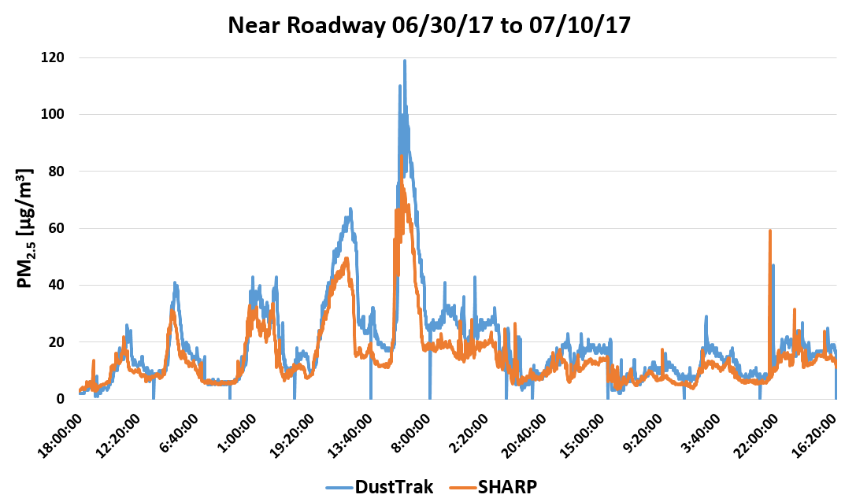
Figure 13. DustTrak versus SHARP at Near Roadway Site

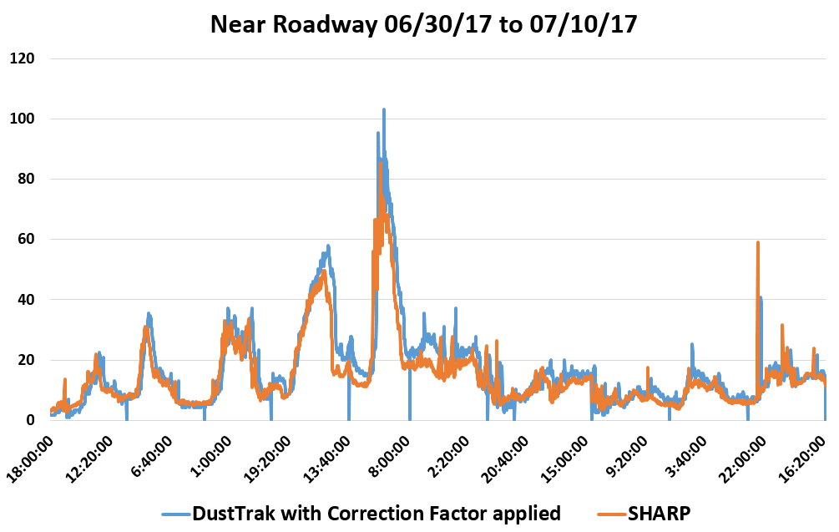
Figure 14. DustTrak with Correction Factor versus SHARP at Near Roadway Site

Our results for one of the three commute studies were unexpected. For Molly’s commute, it was thought that since her windows were up and the air conditioning was on that there would not be high concentrations of BC in that microenvironment. The map results (Fig. 9) show that during her morning commute on 07/05/17 her BC concentrations got as high as 2.52 while driving south on I-75 around the Lincoln Heights area. One plausible source of elevated traffic is General Electric’s (GE) Aviation manufacturing building, which is located in this area of I-75 and brings a lot of traffic from workers and trucks along that route. Looking at the morning and afternoon BC averages (Fig.6), her BC concentrations were still fairly low in comparison to Dexter’s, never going above 2.5µg/m³. The results from Kat’s commute were expected. Looking at the morning and afternoon BC averages (Fig.5), the concentrations from her commutes were never above 1µg/m³. Some of her averages were negative which were omitted from this data set (as they could indicate instrument error or extremely low BC concentrations). She drives a newer vehicle and recently had her in-cabin filters serviced. In addition, she drives back roads that do not have a great volume of traffic (mostly cars; some trucks) along her route. Dexter’s results were expected. We hypothesized that since he was driving with his windows down that he would have a greater concentration of BC in his microenvironment. The morning and afternoon BC averages (Fig. 7) for his commutes show that his concentrations ranged from <1-6.5µg/m³. From these results we can conclude that driving in traffic-heavy areas or on the highway with your windows down can make you more susceptible to exposure to high concentrations of air pollutants such as BC.
There were moderate concentrations of PM_{2.5} and BC on the shuttles. The dose of PM_{2.5} and BC is low for shuttle riders. Based on the National Ambient Air Quality Standard for PM_{2.5} for 24-hours of 35µg/m³, this would lead us to conclude that they contribute minimally to adverse health effects. However, as suggested by Qian et al. (2017), exposure to lower concentrations of PM_{2.5} has potential health impacts.
Our map results for the walking studies were expected. The maps (Fig. 15-18) show that the BC concentrations significantly drop when there is more distance from a source of air pollution such as cars and trucks. When comparing the averages of UC Shuttle Walk to the Camp Washington Walk #1M (CW#1M), there is a greater concentration of BC present on CW#1M (Fig.12). This is used as a comparison because CW#1K used 90 second data collection points instead of 30 second data collection points (what UC Shuttle Walk and CW#1M used) and CW#2&3 have no BC data because of instrument error that was unknown to us until after going on the walks. These walking studies were conducted on different days at different times and since weather changes day-to-day and affects air pollutant concentrations in the atmosphere, we can conclude that weather could also be a factor as to why the PM_{2.5} and BC concentrations are different. In addition, the terrain of UC and Camp Washington are different. Looking at Fig.19, Camp Washington sits at about 495-506 feet above sea level whereas UC sits at about 804-828 feet. The difference in altitudes could account for various concentrations of air pollutants found within those areas.

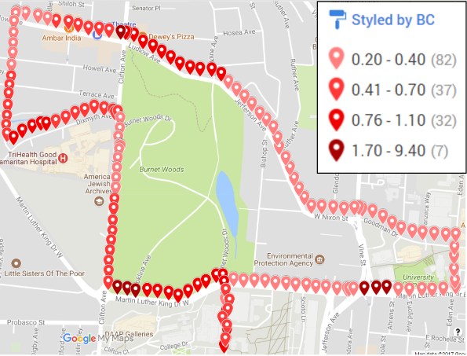
Figure 15. UC Shuttle Walk BC

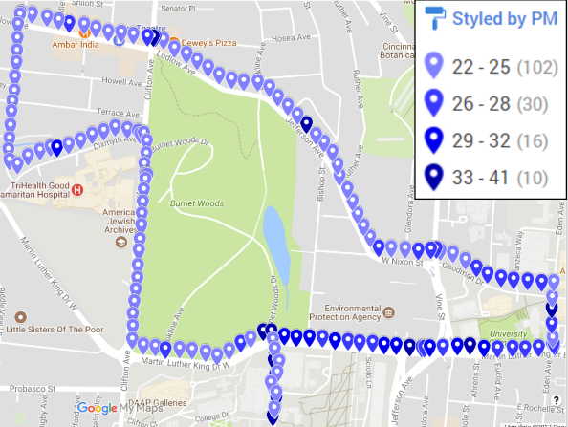
Figure 16. UC Shuttle Walk PM_{2.5}

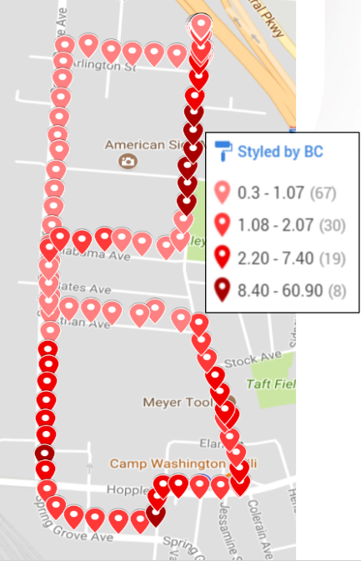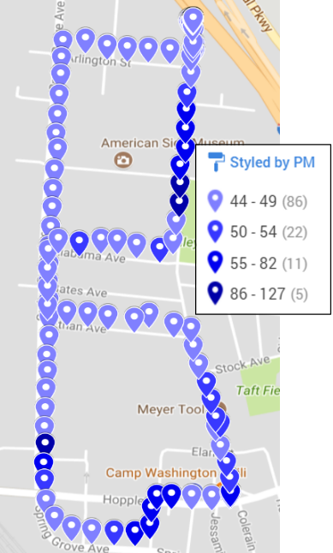
Figure 17. Camp Washington Walk#1M BC Figure 18. Camp Washington Walk#1M PM

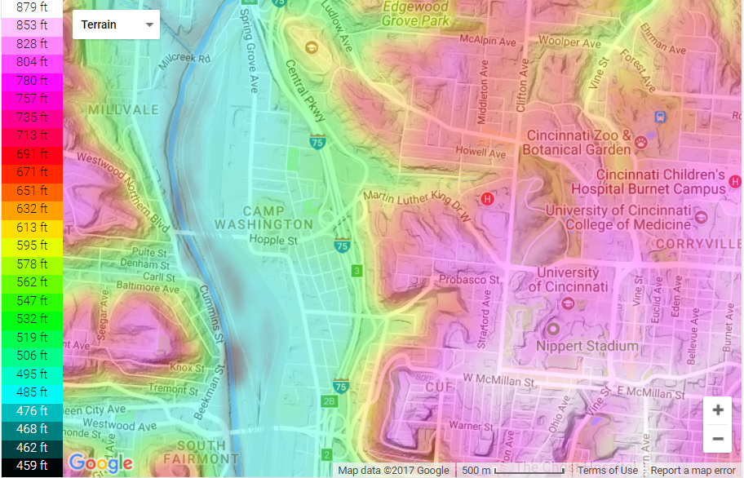
Figure 19. Topographic Terrain Map of Camp Washington and the University of Cincinnati (“Topographic map Cincinnati,” n.d.)

There is a low correlation between BC and 5-minute averages of sound, so five-minute sound averages cannot be used to predict BC concentrations. However, there is a mild correlation between hourly averages of BC and hourly averages of sound (Fig. 20). With further analysis, there is the potential that hourly sound averages could be used to predict BC in certain microenvironments.

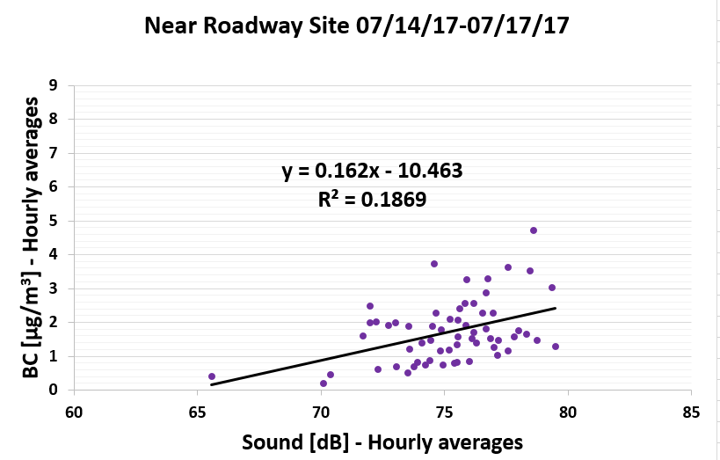Figure 20. Hourly Average of BC versus Hourly Average of Sound at Near Roadway Site

When comparing the average BC/PM_{2.5} ratio at the NR site and the EC/PM_{2.5} Taft site, the NR site is about 11.9% whereas the Taft site is about 5.3%. The NR site is 15-25 feet away from a major roadway, which has a significant impact on air pollutant concentrations, specifically BC. This can have many health implications for those who live, work, go to school, or spend a great deal of time outdoors near a major roadway.
7. RECOMMENDATIONS FOR FUTURE RESEARCH
This work lays the foundation for future work to better understand spatial variability of air pollution at fine spatial scales. First, the correction factor for the DustTrak PM_{2.5} data needs to be verified for different seasons and weather patterns. The commute studies could be continued with a constant vehicle model to get a better comparison on different roadways and at different times throughout the day. More data needs to be collected and analyzed to determine the relationship between sound and BC at the near roadway site, on walks in Camp Washington and around UC’s campus. Additional walks on the shuttle routes should be conducted at the same time as onboard shuttle routes for better comparison between data sets.
8. CLASSROOM IMPLEMENTATION PLANS
Kat plans on implementing her unit with her 11th and 12th grade AP Environmental Science students in January of 2018 when they return from Christmas break. The big idea for this lesson is on air pollution and air quality. The challenge will be for them to design an air filtration device that can filter indoor air pollutants (specifically particulate matter). The students will present and defend their solution by creating a sales pitch to get someone to buy their device to make and sell/donate to those living in developing countries that are greatly affected by indoor air pollution. Once they have all presented, each student in the class will rank the groups in descending order (5,4,3,2,1--5 meaning the one they liked the most, 1 meaning the one they liked the least) to see which groups’ idea ranks the highest amongst their peers.
Molly will be introducing the Big Idea of noise pollution and sound to her students in late January. The challenge will be to create and evaluate a product that will increase a sound so an audience can hear it. Students will create a public service video, announcement, or brochure to inform the entire school population about sound, safe volume levels, the volume required for a performance to be heard, risks, and suggested methods to reduce exposure, as well as their solution to the challenge.
9. ACKNOWLEDGEMENTS
NSF Grant # EEC-1404766 “Challenge-Based Learning and Engineering Design Process Enhanced Research Experiences for Middle and High School In-Service Teachers”
10. BIBLIOGRAPHY
“AethLabs.” (n.d.). AethLabs, <https://aethlabs.com/microaeth/ae51/tech-specs> (Jul. 7, 2017).

Beelen, R., Hoek, G., Houthuijs, D., Brandt, P. A. V. D., Goldbohm, R. A., Fischer, P., Schouten, L. J., Armstrong, B., and Brunekreef, B. (2008). “The joint association of air pollution and noise from road traffic with cardiovascular mortality in a cohort study.” Occupational and Environmental Medicine, 66(4), 243–250.

Bond, T. C., Doherty, S. J., Fahey, D. W., Forster, P. M., Berntsen, T., DeAngelo, B. J., Flanner, M. G., Ghan, S., Karcher, B., Koch, D., Kinne, S., Kondo, Y., Quinn, P. K., Sarofim, M. C., Schultz, M. G., Schulz, M., Venkataraman, C., Zhang, H., Zhang, S., Bellouin, N., Guttikunda, S. K., Hopke, P. K., Jacobson, M. Z., Kaiser, J. W., Klimont, Z., Lohmann, U., Schwarz, J. P., Shindell, D., Storelvmo, T., Warren, S. G., and Zender, C. S. (2013). “Bounding the role of black carbon in the climate system: A scientific assessment.” Journal of Geophysical Research, 118(11), 5380–5552.

Betancourt, R. M., Galvis, B., Balachandran, S., Ramos-Bonilla, J., Sarmiento, O., Gallo-Murcia, S., and Contreras, Y. (2017). “Exposure to fine particulate, black carbon, and particle number concentration in transportation microenvironments.” Atmospheric Environment, 157, 135–145.

Cheung, K., Daher, N., Kam, W., Shafer, M. M., Ning, Z., Schauer, J. J., and Sioutas, C. (2011). “Spatial and temporal variation of chemical composition and mass closure of ambient coarse particulate matter (PM10–2.5) in the Los Angeles area.” Atmospheric Environment, 45(16), 2651–2662.

“Clean Air Act Title IV - Noise Pollution.” (2017). EPA, Environmental Protection Agency, <https://www.epa.gov/clean-air-act-overview/clean-air-act-title-iv-noise-pollution> (Jun. 23, 2017).

“Criteria Air Pollutants.” (2017). EPA, Environmental Protection Agency, <https://www.epa.gov/criteria-air-pollutants> (Jun. 23, 2017).

Di, Q., Wang, Y., Zanobetti, A., Wang, Y., Koutrakis, P., Choirat, C., Dominici, F., and Schwartz, J. “Air Pollution and Mortality in the Medicare Population.” The New England Journal of Medicine, 376, 2513-2522.

“DustTrak II Aerosol Monitor 8530.” (n.d.). DUSTTRAK II Aerosol Monitor 8530; Area Aerosol Monitors, <http://www.tsi.com/dusttrak-ii-aerosol-monitor-8530/> (Jul. 7, 2017).

Fecht, D., Hansell, A. L., Morley, D., Dajnak, D., Vienneau, D., Beevers, S., Toledano, M. B., Kelly, F. J., Anderson, H. R., and Gulliver, J. (2016). “Spatial and temporal associations of road traffic noise and air pollution in London: Implications for epidemiological studies.” Environment International, 88, 235–242.

Harrison, R. M., and Yin, J. (2000). “Particulate matter in the atmosphere: which particle properties are important for its effects on health?” Science of the Total Environment, 249(1-3), 85–101.

Hoek, G., Brunekreef, B., Goldbohm, S., Fischer, P., and Brandt, P. A. V. D. (2002). “Association between mortality and indicators of traffic-related air pollution in the Netherlands: a cohort study.” The Lancet, 360(9341), 1203–1209.

Kheirbek, I., Ito, K., Neitzel, R., Kim, J., Johnson, S., Ross, Z., Eisl, H., and Matte, T. (2014). “Spatial Variation in Environmental Noise and Air Pollution in New York City.” Journal of Urban Health, 91(3), 415–431.

Laden, F., Neas, L. M., Dockery, D. W., and Schwartz, J. (2000). “Association of Fine Particulate Matter from Different Sources with Daily Mortality in Six U.S. Cities.” Environmental Health Perspectives, 108(10), 941–947.

“Neighborhood Life Expectancy Data.” (n.d.). Home - City of Cincinnati, <http://www.cincinnati-oh.gov/health/community-health-data/neighborhood-life-expectancy-data/> (Jul. 21, 2017).

Thermo Fisher Scientific. (2011). Model 5030i SHARP Instruction Manual.

“Topographic map Cincinnati.” (n.d.). topographic-map.com, <http://en-us.topographic-map.com/places/Cincinnati-365423/> (Jul. 21, 2017).
11. APPENDIX I: NOMENCLATURE USED
AE51 = microAeth® AE51 monitor
BC = black carbon
dB = decibels
DustTrak = DustTrak II Aerosol Monitor 8530
GPS = Global Positioning System
NR Site = Near Roadway site
PM_{1.0}= particulate matter size 1.0 micrometers
PM_{2.5}= particulate matter size 2.5 micrometers
PM₁₀= particulate matter size 10 micrometers
R² = coefficient of determination
SHARP = Synchronized Hybrid Ambient Real-time Particulate
SWOAQA = Southwest Ohio Air Quality Agency
Sound monitor = Extech 407760: USB Sound Level Datalogger
UC = University of Cincinnati
µg/m³ = micrograms per cubic meter
12. APPENDIX II: RESEARCH SCHEDULE
12.1 06/19/17 - 06/23/17
The first week of research was dedicated to learning about the monitors that were used to conduct the research study. The AE51 and Dust] Trak monitors were used to research concentrations of black carbon (BC) and particulate matter (PM_{2.5}) in the air respectively. A few trials were run using these monitors and then the data was downloaded in Excel. Trials were done with the monitors and the ‘GeoTracker’ phone application to look at air pollution data related to GPS coordinates along certain routes taken. Basic statistics and data analysis was introduced.
12.2 06/26/17 - 06/30/17
Week 2 research focused on collecting data for several consecutive days at the near roadway site. On June 27, NIOSH (Lina Zheng) set up their metals detector at the near roadway site. The metals detector is an aerosol spark emission spectrometer that can detect concentrations of Iron, Silicon, and Titanium in the air. Also, sound data was collected from two sound data loggers at the near roadway site. The sound data loggers are Extech 407760 USB sound data loggers. Metals and sound data was also collected on June 28. During this week, data was collected from commutes and shuttle bus trips around campus. Worked on mapping BC, PM_{2.5}, and GPS data on Google Maps. Data analysis continued.
12.3 07/03/17 - 07/07/17
The third week included a continuation of data collection for consecutive days at the near roadway site, on commutes, and on campus shuttle runs. Walks around campus were used to collect data as well. Data analysis continued.
12.4 07/10/17 - 07/14/17
During week 4, data collection was continued for consecutive days at the near roadway site, on commutes, and on campus shuttle runs. Walks around campus and Camp Washington were also conducted. Data analysis continued. Started analyzing SWOAQA data and comparing DustTrak to SHARP.
12.5 07/17/17 - 17/21/17
Data collection concluded during Week 5 at the near roadway data. Sound data was collected over the weekend and ended on Monday. A final walk around Camp Washington was done on Monday. Data Analysis continued with a focus on determining results, conclusions and recommendations. RET participants went on a field trip the Southwest Ohio Air Quality Agency, located at 250 William Howard Taft Rd., Cincinnati, OH 45219..
13. APPENDIX III: TABLES, GRAPHS, FIGURES, IMAGES

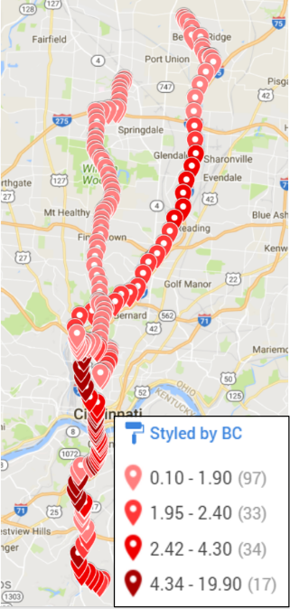
Figure 21. Commutes on Morning of 07/05/17

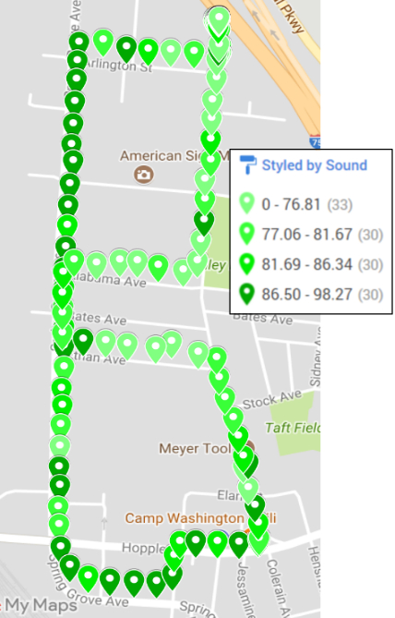
Figure 22. Camp Washington Walk#1M Sound

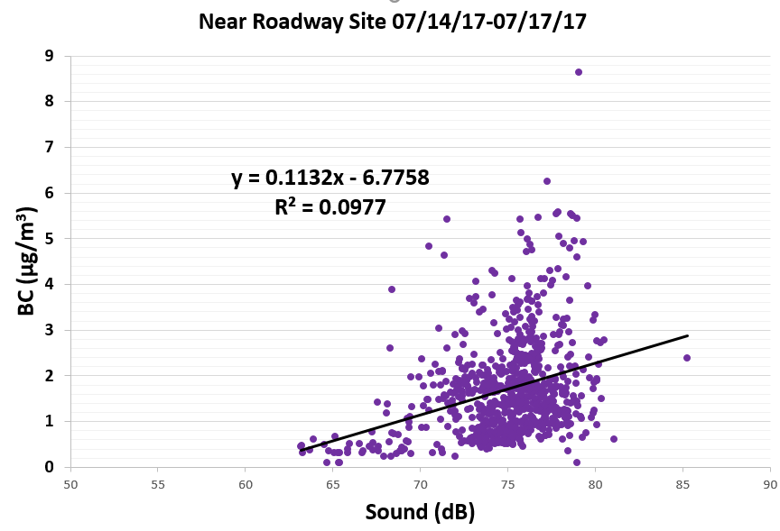
Figure 23. BC versus Sound at Near Roadway Site

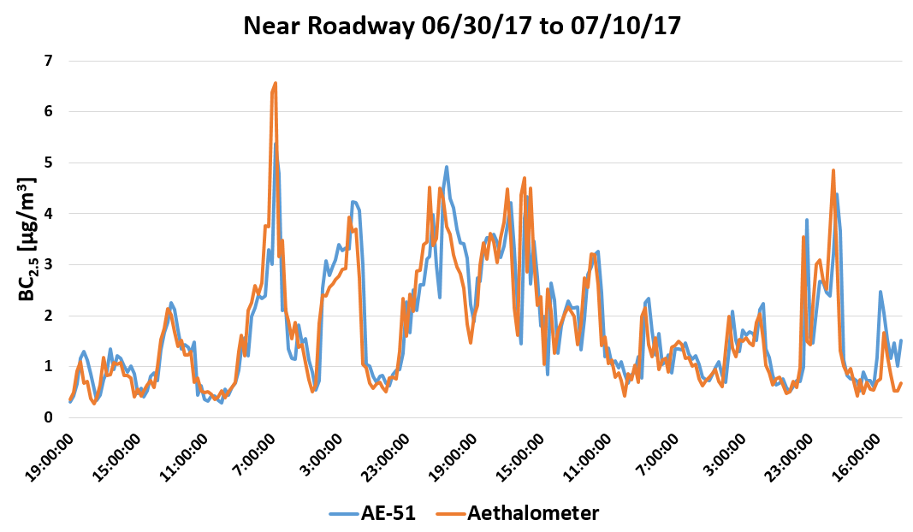
Figure 24. AE-51 versus Aethalometer at Near Roadway Site
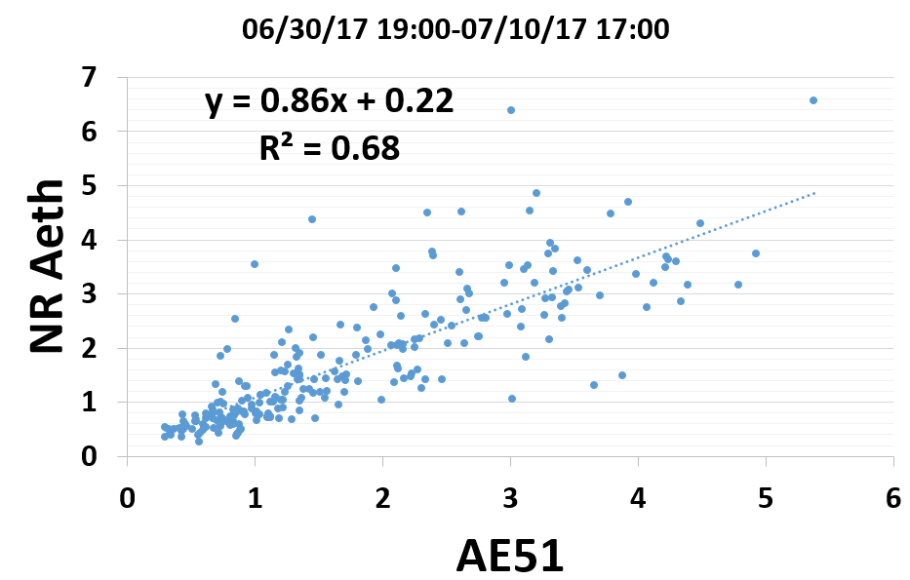
Figure 25. AE-51 versus Aethalometer at Near Roadway Site

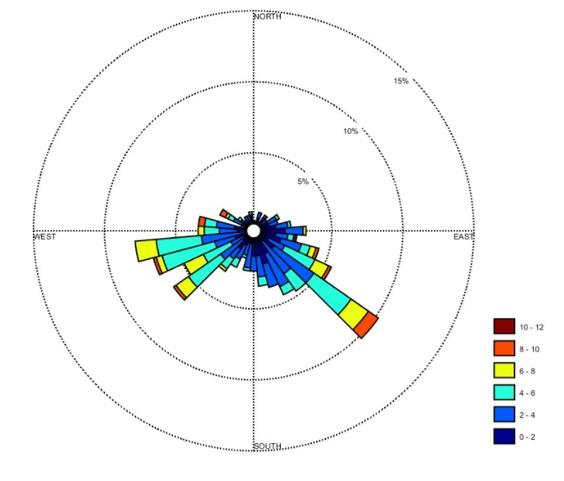

Figure 26. Wind Rose Chart (m/s) at Near Roadway Site 06/30/17 to 07/12/17

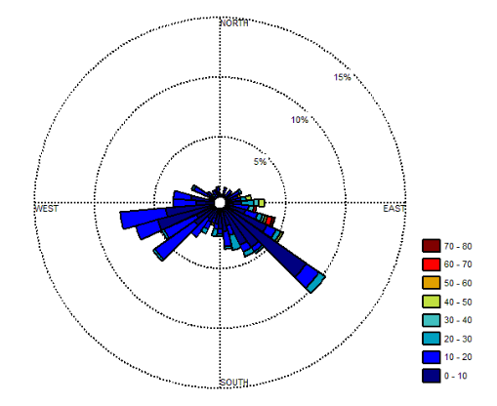

Figure 27. PM_{2.5} Wind Rose Chart (µg/m³) at Near Roadway Site 06/30/17 to 07/12/17

14. APPENDIX IV: KAT’S UNIT TEMPLATE
Name: Kat Roedig | Contact Info: kroedig0812@gmail.com | Date: 26-Jun-17

Unit Number and Title: Unit 1 Air Pollution and Air Quality

Grade Level: | 11-12
Subject Area: | AP Environmental Science

Total Estimated Duration of Entire Unit: | 2.5 weeks

Part 1: Designing the Unit
- Unit Academic Standards (Identify which standards: NGSS, OLS and/or CCSS. Cut and paste from NGSS, OLS and/or CCSS and be sure to include letter and/or number identifiers.):
College Board for Advanced Placement Environmental Science themes covered: 1. Science is a process, 4. Humans alter natural systems, 5. Environmental problems have a cultural and social context, 6. Human survival depends on developing practices that will achieve sustainable systems. College Board for Advanced Placement Environmental Science topics covered: VI. Pollution: A. Pollution types, 1. Air pollution; B. Impacts on the environment and human health, 1. Hazards to human health.

- Unit Summary
The Big Idea (including global relevance):
The Big Idea: Air Pollution/Air Quality
Global Relevance: Global warming, climate change, global emissions, Clean Air Act, Paris Climate Agreement, National Ambient Air Quality Standards (NAAQS)

The (anticipated) Essential Questions: List 3 or more questions your students are likely to generate on their own. (Highlight in yellow the one selected to define the Challenge):
How can you control emissions of air pollutants from the source?
How can you protect yourself from air pollutants?
Where do air pollutants come from?
What health effects are there from inhaling air pollutants?

- Unit Context
Justification for Selection of Content– Check all that apply:
☐ Students previously scored poorly on standardized tests, end-of term test or any other test given in the school or district on this content.
X Misconceptions regarding this content are prevalent.
X Content is suited well for teaching via CBL and EDP pedagogies.
X The selected content follows the pacing guide for when this content is scheduled to be taught during the school year. (Unit 1 covers atomic structure because it is taught in October when I should be conducting my first unit.)
☐ Other reason(s) _____________________________________________________________
_____________________________________________________________________________

The Hook: (Describe in a few sentences how you will use a “hook” to introduce the Big Idea in a compelling way that draws students into the topic.)
The hook that I will use to introduce the Big Idea will be to show the video “How Deadly is Air Pollution?” done by CNN. This brief video shows some nice graphics and statistics about air pollution across the world.
http://www.cnn.com/videos/health/2016/09/27/air-pollution-deadly-orig.cnn
The Challenge and Constraints:
Design an air filtration device that can filter indoor air pollutants (specifically particulate matter).
To test: Make a box that the device will go in/on—poke holes in the top to put hose through for monitoring PM—put filter in box and turn in, then light incense and turn on device and test for a certain amount of time to see how much it filters/reduces the amount of PM in the box over time. Use a DustTrak monitor from our RET program to test the amount of PM.
X Product or ☐ Process (Check one)

Description of Challenge (Either Product or Process is clearly explained below): | List the Constraints Applied
Design an air filtration device that could filter indoor air pollutants (specifically particulate matter). | Box—size  Dust matter introduced  Time air filtration device is in box filtering air  Creating own filter—not given one  Finite supply of materials (given a budget)  Solar fan used to pull air through device for 5 minutes and air quality is measured  Reduce by a certain percentage  Filter size must meet certain dimensions or thickness

Teacher’s Anticipated Guiding Questions (that apply to the Challenge and may change with student input.):
What causes air pollution? What are anthropogenic causes of air pollution? What are natural causes of air pollution?
What are some devices that control air pollution emissions?
What kind of materials trap particulate matter?
What methods are used for measuring particulate matter?
What are differences between indoor/outdoor air pollution?

4. EDP: Use the diagram below to help you complete this section.
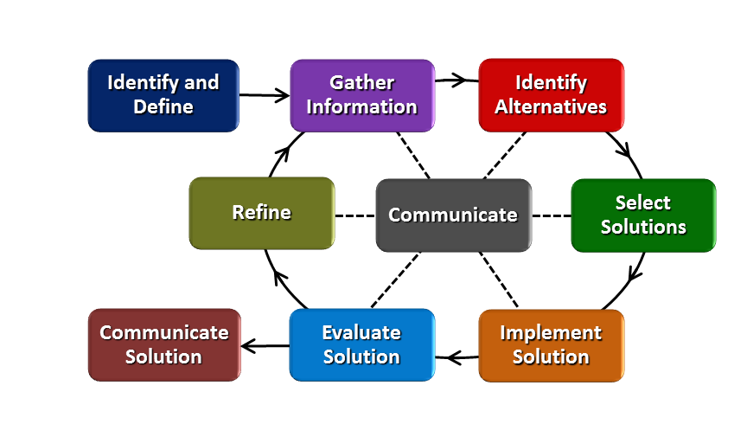
How will students test or implement the solution? What is the evidence that the solution worked? Describe how the iterative process from the EDP applies to your Challenge.
Students will be given materials: solar car cooling system (or solar panel connected to computer fan), cardboard, poster board, a roll of tape (have students create their own filter do not provide them with one—research this and re-create something that will filter the air effectively—maybe give cotton balls or gauze, microfiber rags, Swiffer wipes). The students will build their air filtration device and test it out in a box that simulates a home in a developing country. This box will have holes poked in the top for me to insert the hose for the DustTrak monitor and will also have burning incense inside to simulate indoor air pollution from cooking. The students will place their device in the box; incense will be lit; and they will start collecting data using the DustTrak monitor for 1 minute with just the incense; then they will start their device and let it run for 5 minutes and see if their device reduced the amount of particulate matter in the box. The evidence that shows the solution worked is if they reduce the amount of particulate matter detected inside the box after the device is on and in the box for 5 minutes. They can test their device and I could change the challenge and say that it needs to be reduced by a certain percentage to see if they could improve it in another way to make it more effective to make the EDP process iterative.
How will students present or defend the solution? Describe if any formal training or resource guides will be provided to the students for best practices (e.g., poster, flyer, video, advertisement, etc.) used to present work.
They will present their solution as if they were marketing their device to people who live in third world countries who are affected most by indoor air pollutants (specifically particulate matter from biomass burning used to heat their homes and cook meals). Have the students vote on the solutions they like the best (rank 4, 3, 2, 1, etc.).
What academic content is being taught through this Challenge?
Major air pollutants, causes, and health effects; air pollution control methods—more specifically through the following activities: major air pollutants, causes and health effects chart/notes; air quality survey lab; air pollution control methods chart/notes; wet scrubber and air pollution lab; Vernier particulate matter activity; air pollution and vehicle exhaust lab; introduce challenge and start designing and testing their device.
Assessment and EDP:
Using the diagram above, identify any places in the EDP where assessments should take place, as it applies to your Challenge. Describe below what kinds of assessment are most appropriate.
I have made a worksheet to go along with the Challenge, and before students can move on to the next part I will check their previous part and give them advice and tell them to move on to the next part or keep working on the current part. There is a section on the worksheet where the teacher needs to initial before they can move on to the next part.

What EDP Processes are ideal for conducting an Assessment? (List ones that apply.) | List the type of Assessment (Rubric, Diagram, Checklist, Model, Q/A etc.) Check box to indicate whether it is formative or summative.
Identify and Define  Gather Information  Identify Alternatives  Select the Best Solution  Implement the Solution  Evaluate the Solution  Refine  Communicate Solution | Worksheet Check X formative ☐ summative  Worksheet Check X formative ☐ summative  Worksheet Check X formative ☐ summative  Worksheet Check X formative ☐ summative  Worksheet Check and Testing Device X formative ☐ summative  Worksheet Check and Testing Device X formative ☐ summative  Worksheet Check X formative ☐ summative  Presentation of Device ☐ formative X summative
Check below which characteristic(s) of this Challenge will be incorporated in its implementation using EDP. (Check all that apply.)
X Has clear constraints that limit the solutions
X Will produce than one possible solution that works
X Includes the ability to refine or optimize solutions
X Assesses science or math content
X Includes Math applications
☐ Involves use of graphs
X Requires analysis of data
X Includes student led communication of findings

5. ACS (Real world applications; career connections; societal impact):
Place an X on the continuum to indicate where this Challenge belongs in the context of real world applications:
Abstract or Loosely Applies to the Real World | |--------------------------------------|--------------------X------------------| | Strongly Applies to the Real World

Provide a brief rationale for where you placed the X: Many people who live in developing countries do not have access to electricity, so they burn biomass to heat their homes and also to cook their meals. Burning this biomass in an enclosed space emits a lot of particulate matter and other air pollutants into the air that harm these people. Creating something easy to use and practical to help filter their air indoors would let them use the same techniques that are available but also have the availability of clean air while doing so.
What activities in this Unit apply to real world context? Introduction to major air pollutants, causes and health effects chart/notes; air quality survey lab; air pollution control methods chart/notes; wet scrubber and air pollution lab; Vernier particulate matter activity; air pollution and vehicle exhaust lab; challenge.

Place an X on the continuum to indicate where this Challenge belongs in the context of societal impact:
Shows Little or No Societal Impact | |-------------------------------------|--------------------X-------------------| | Strongly Shows Societal Impact

Provide a brief rationale for where you placed the X: This challenge (and unit) should help students understand more about how indoor air pollutant is a huge health concern not only in developing countries but also in developed countries.
What activities in this Unit apply to societal impact? Introduction to major air pollutants, causes and health effects chart/notes; air quality survey lab; air pollution control methods chart/notes; wet scrubber and air pollution lab; Vernier particulate matter activity; air pollution and vehicle exhaust lab; challenge; Paris Climate Agreement.

Careers: What careers will you introduce (and how) to the students that are related to the Challenge? (Examples: career research assignment, guest speakers, fieldtrips, Skype with a professional, etc.)
The careers that I will introduce are environmental and materials engineering and have either a guest speaker come in or Skype with one of our GRAs.

6. Misconceptions:
May not understand indoor versus outdoor air pollutants and how those are different in developed versus developing countries.
Just because they are one person there is nothing they can do to help improve air quality
7. Unit Lessons and Activities: (Provide a tentative timeline with a breakdown for Lessons 1 and 2. Provide the Lesson #’s and Activity #’s for when the Challenge Based Learning (CBL) and Engineering Design Process (EDP) are embedded in the unit.)

Lesson 1: The causes of air pollutants and methods used to control air pollutants (4 days)
Activity #1: Introduction to big idea, hook, essential questions; introduction to major air pollutants, causes and health effects chart/notes; air quality survey lab (2 days: normal time)
Activity #2: Air pollution control methods chart/notes; Wet scrubbers and air pollution lab (2 days: normal time and extended lab period)
Lesson 2: Pollution types and designing and testing their device (4 days)
Activity #3: Air pollution and vehicle exhaust lab (2 days: normal time)
Activity #4: Introduction to indoor air pollutants, causes and health effects chart/notes; introduce the challenge and design and test their device (2 days: extended lab period) (CBL and EDP)
CBL: Activity 1 and 4
EDP: Activity 4
(**My schedule is that each class meets 3 times a week; 2 times for 70 minutes and 1 time for 1 hour and 55 minutes—1 day could either be 70 minutes or 1 hour and 55 minutes)

8. Keywords:
Air pollution, particulate matter, Clean Air Act, National Ambient Air Quality Standards.

9. Additional Resources:
“Indoor Air pollution Kills Thousands in India”.
http://video.aljazeera.com/channels/eng/videos/indoor-air-pollution-kills-thousands-in-india/4679671008001
Other good videos to use during lesson and activities:
https://www.youtube.com/watch?v=11oawjSncYM
http://www.bbc.com/news/av/science-environment-39170488/what-does-air-pollution-do-to-our-bodies
10. Pre-Unit and Post-Unit Assessment Instruments:

11. Poster | 12. Video (Link here.)

If you are a science teacher, check the boxes below that apply:
Next Generation Science Standards (NGSS)
Science and Engineering Practices (Check all that apply) | Crosscutting Concepts (Check all that apply)
X Asking questions (for science) and defining problems (for engineering) | ☐ Patterns
X Developing and using models | X Cause and effect
X Planning and carrying out investigations | ☐ Scale, proportion, and quantity
X Analyzing and interpreting data | ☐ Systems and system models
☐ Using mathematics and computational thinking | ☐ Energy and matter: Flows, cycles, and conservation
X Constructing explanations (for science) and designing solutions (for engineering) | ☐ Structure and function.
X Engaging in argument from evidence | ☐ Stability and change.
X Obtaining, evaluating, and communicating information

If you are a science teacher, check the boxes below that apply:
Ohio’s Learning Standards for Science (OLS)
Expectations for Learning - Cognitive Demands (Check all that apply)
X Designing Technological/Engineering Solutions Using Science concepts (T)
X Demonstrating Science Knowledge (D)
X Interpreting and Communicating Science Concepts (C)
X Recalling Accurate Science (R)

If you are a math teacher, check the boxes below that apply:
Ohio’s Learning Standards for Math (OLS) or
Common Core State Standards -- Mathematics (CCSS)
Standards for Mathematical Practice (Check all that apply)
☐ Make sense of problems and persevere in solving them | ☐ Use appropriate tools strategically
☐ Reason abstractly and quantitatively | ☐ Attend to precision
☐ Construct viable arguments and critique the reasoning of others | ☐ Look for and make use of structure
☐ Model with mathematics | ☐ Look for and express regularity in repeated reasoning

Part 2: Post Implementation- Reflection on the Unit
Results: Evidence of Growth in Student Learning - After the Unit has been taught and the Post-Unit Assessment Instrument has been used to assess student growth in learning, the teacher must analyze the data and determine whether or not student growth in learning occurred. Present all documents used to collect and organize Post- Unit evaluation data such as graphs or charts. Provide a written analysis in sentence or paragraph form which provides the evidence that student growth in learning took place. Please present results and, if applicable, student work (as a hyperlink) used as evidence after the Unit has been taught.

Please include:
- Any documents used to collect and organize post unit evaluation data. (charts, graphs and /or tables etc.)
- An analysis of data used to measure growth in student learning providing evidence that student learning occurred. (Sentence or paragraph form.)
- Other forms of assessment that demonstrate evidence of learning.
- Anecdotal information from student feedback.

Reflection: Reflections: Reflect upon the successes of teaching in this Unit in 5 or more sentences in the form of a narrative. Consider the following questions:
- Why did you select this content for the Unit?
- Was the purpose for selecting the Unit met? If yes, provide student learning related evidence. If not, provide possible reasons.
- Did the students find a solution or solutions that resulted in concrete meaningful action for the Unit’s Challenge? Hyperlink examples of student solutions as evidence.
- What does the data indicate about growth in student learning?
- What would you change if you re-taught this Unit?
- Would you teach this Unit again? Why or why not?

15. APPENDIX V: MOLLY’S UNIT TEMPLATE
Name: Molly Hamilton | Contact Info: hamilmo@cpsboe.k12.oh.us | Date: 07/06/17

Unit Number and Title: Unit 4 Series, Exponential, and Logarithmic Functions: How is Sound Measured – How can you change the volume of a sound?

Grade Level: | 10-11
Subject Area: | Algebra 2 AA

Total Estimated Duration of Entire Unit: | Ten 45 minute classes

Part 1: Designing the Unit
- Unit Academic Standards (Identify which standards: NGSS, OLS and/or CCSS. Cut and paste from NGSS, OLS and/or CCSS and be sure to include letter and/or number identifiers.):
LE.A.4 For exponential models, express as a logarithm the solution to abct = d where a, c, and d are numbers and the base b is 2, 10, or e; evaluate the logarithm using technology.
IF.C.7 Graph functions expressed symbolically and show key features of the graph, by hand in simple cases and using technology for more complicated cases.
IF.C.7e Graph exponential and logarithmic functions, showing intercepts and end behavior, and trigonometric functions, showing period, midline, and amplitude.
CED.A.4 Rearrange formulas to highlight a quantity of interest, using the same reasoning as in solving equations. For example, rearrange Ohm’s law V = IR to highlight resistance R.
REI.D.11 Explain why the x-coordinates of the points where the graphs of the equations y = f(x) and y = g(x) intersect are the solutions of the equation f(x) = g(x); find the solutions approximately, e.g., using technology to graph the functions, make tables of values, or find successive approximations. Include cases where f(x) and/or g(x) are linear, polynomial, rational, absolute value, exponential, and logarithmic functions.

- Unit Summary
The Big Idea (including global relevance): Noise pollution and Sound: How can you change the volume of a sound? Noise pollution is all around us. It is any annoying or distressing sound that interferes with sleep, daily activities or negatively affects one’s quality of life (“Clean Air Act Title IV - Noise Pollution,” 2017), but it really depends on an individual’s perspective. It can cause temporary or permanent hearing loss. However, even noises that are not considered pollution can damage one’s hearing. Sounds are used or manipulated for many different reasons: alarms, emergency notification, communication, music, interference, expression, and to add depth to a scene or environment, as well as many more.

The (anticipated) Essential Questions: List 3 or more questions your students are likely to generate on their own. (Highlight in yellow the one selected to define the Challenge):
Why would we want to make a sound louder?
Why would we want to make a sound quieter?
What risks are there from being exposed to loud sounds?
Why can’t I hear a certain sound?
Should I be able to hear a soft sound?
How loud is my music?
How can we manipulate sound?
How can we make a sound louder or quieter?

- Unit Context
Justification for Selection of Content– Check all that apply:
☐ Students previously scored poorly on standardized tests, end-of term test or any other test given in the school or district on this content.
x Misconceptions regarding this content are prevalent.
x Content is suited well for teaching via CBL and EDP pedagogies.
x The selected content follows the pacing guide for when this content is scheduled to be taught during the school year. (Unit 1 covers atomic structure because it is taught in October when I should be conducting my first unit.)
☐ Other reason(s) _____________________________________________________________
_____________________________________________________________________________

The Hook: (Describe in a few sentences how you will use a “hook” to introduce the Big Idea in a compelling way that draws students into the topic.)
Students will complete a hearing test online to see if they have any hearing loss. Students will also identify the loudest and quietest environments they are in during the course of their day/week.

The Challenge and Constraints:

x Product or ☐ Process (Check one)

Description of Challenge (Either Product or Process is clearly explained below): | List the Constraints Applied
Create and evaluate a product that will increase a sound so an audience can hear it. | Students will be required to use common resources to design and build a sound amplifier.  Students will be given 2 days to design, build, evaluate, redesign, modify, reevaluate, etc, (following EDP).  Sound will be measured at a distance of 5 feet and compared to an initial measurement.  Students will be given additional constraint of needing to double or triple the distance that the sound can be heard.

Teacher’s Anticipated Guiding Questions (that apply to the Challenge and may change with student input.):

How do we measure sound?
What level of sound is considered safe?
What organization determines what level of sound is safe?
How do we minimize our exposure to dangerous sounds?
What materials have been effective in other applications?
What can we do besides use electronics?
How can this information help students in this school?
How might this resource be used?
How do we amplify sound?

4. EDP: Use the diagram below to help you complete this section.
How will students test or implement the solution? What is the evidence that the solution worked? Describe how the iterative process from the EDP applies to your Challenge.
Students will collect baseline sound data. Then they will research and develop a product or process to increase the volume of a sound so an audience can hear it. They will design and build a sound amplifier and test the volume of the sound. Then they will try to revise to improve even more. The evidence will come from the data they collect before and after implementation.
How will students present or defend the solution? Describe if any formal training or resource guides will be provided to the students for best practices (e.g., poster, flyer, video, advertisement, etc.) used to present work.
Students will create a Public Service Video, Announcement, or Brochure to inform the entire school population about sound, safe volume levels, the volume required for a performance to be heard, risks, and suggested methods to reduce exposure.
What academic content is being taught through this Challenge?
Students will learn about logarithmic scales, why they are used, and what information they provide.
Assessment and EDP:
Using the diagram above, identify any places in the EDP where assessments should take place, as it applies to your Challenge. Describe below what kinds of assessment are most appropriate.

What EDP Processes are ideal for conducting an Assessment? (List ones that apply.) | List the type of Assessment (Rubric, Diagram, Checklist, Model, Q/A etc.) Check box to indicate whether it is formative or summative.
Design options  Product Test  Communicate solution  Posttest | Drawings/Sketches x formative ☐ summative  Rubric x formative ☐ summative  Rubric ☐ formative x summative  Multiple choice test ☐ formative x summative
Check below which characteristic(s) of this Challenge will be incorporated in its implementation using EDP. (Check all that apply.)
☐ Has clear constraints that limit the solutions
x Will produce more than one possible solution that works
x Includes the ability to refine or optimize solutions
x Assesses science or math content
x Includes Math applications
☐ Involves use of graphs
x Requires analysis of data
x Includes student led communication of findings

5. ACS (Real world applications; career connections; societal impact):
Place an X on the continuum to indicate where this Challenge belongs in the context of real world applications:
Abstract or Loosely Applies to the Real World | |--------------------------------------|--------------------------------------x| | Strongly Applies to the Real World

Provide a brief rationale for where you placed the X:_Sound is something we encounter on a daily basis. An important aspect of sound is making sure that we are hearing sound at an acceptable range. Another side to that is that sound needs to be loud enough to be heard. At SCPA, students are frequently performing for an audience. They rely on electronics to amplify the various sounds that they are producing. What would happen if they didn’t have access to these electronics? ___________________________________________________________________________________
What activities in this Unit apply to real world context? All activities apply to real world context.

Place an X on the continuum to indicate where this Challenge belongs in the context of societal impact:
Shows Little or No Societal Impact | |-------------------------------------|x---------------------------------------| | Strongly Shows Societal Impact

Provide a brief rationale for where you placed the X: A good solution can be used to share performance arts with the community. Students will spread the word about their research and solutions through a public service announcement, video, or brochure. This product could be used for people with temporary or permanent (partial) hearing loss, or to enhance communication, music, or artistic performance. ___________________________________________________________________________________

What activities in this Unit apply to societal impact? In Activity 4, students will be creating and designing a product that will increase a sound. This idea could be used to help people with temporary or permanent (partial) hearing loss. Throughout the unit students will be learning about safe noise levels and how to monitor the sound around them.

Careers: What careers will you introduce (and how) to the students that are related to the Challenge? (Examples: career research assignment, guest speakers, fieldtrips, Skype with a professional, etc.)
Sound Engineer, Singer, Actor, Musician, Sustainability Coordinator, Audiologist, Sound Technician, Forensic Audio Specialist, Audio Archivist, Sound Designer, Recording Engineer/Mixer, Acoustic Consultant, Digital Remastering Engineer, Recording Equipment Representative, Mastering Engineer, Recording Studio Setup Worker, Music Editor, Audio Developer, Sonar technician.

6. Misconceptions:

Quantifying sound – what can we measure and how changing one characteristic of sound effects or another characteristic.
Logarithms, logarithmic scales, and their applications.
7. Unit Lessons and Activities: (Provide a tentative timeline with a breakdown for Lessons 1 and 2. Provide the Lesson #’s and Activity #’s for when the Challenge Based Learning (CBL) and Engineering Design Process (EDP) are embedded in the unit.)

Unit 4: Series, Exponential, and Logarithmic Functions: How is Sound Measured – How can you change the volume of a sound?
Lesson 1: Decreasing the Volume of a Sound – (5 days)
Lesson 1 will focus on giving the students an understanding of sound, how sound is measured, and why and how to decrease the volume of a sound. Students will collect sound data in their environment to see what are the loudest and quietest environments they are in over the course of a day or week.

Activity 1: Introduction of the Big Idea, Generating the Essential Question, Challenge and Guiding
Questions. (2.5 days)
Activity 2: Determine what frequencies they can hear and how far away they can hear them. (2.5
days)

Lesson 2: Increasing the Volume of a Sound – (5 days)
Lesson 2 will focus on understanding decibels, logarithms, and why and how to increase the volume of a sound. Students will collect data about how far away they can hear different frequencies.

Activity 3: Determine how far away a certain frequency can be heard at a given decibel level. (1
day)
Activity 4: Create a noise amplifier. (4 days)

CBL: Lesson 2, Activity 4
EDP: Lesson 2, Activity 4
8. Keywords:

Frequency, intensity, pitch, decibels, logarithms, sound amplifier.
9. Additional Resources:

https://hearingtest.online
http://www.starkey.com/online-hearing-test
www.sciencebuddies.org/science-fair-projects/project_ideas/HumBio_p011.shtml
https://www.youtube.com/watch?v=-_YR1jnGyMY or
http://pbskids.org/dragonflytv/show/extremesounds.html

10. Pre-Unit and Post-Unit Assessment Instruments:

Unit 4 Sound Pre-assessment
Unit 4 Post-assessment
11. Poster | 12. Video (Link here.)

If you are a science teacher, check the boxes below that apply:
Next Generation Science Standards (NGSS)
Science and Engineering Practices (Check all that apply) | Crosscutting Concepts (Check all that apply)
x Asking questions (for science) and defining problems (for engineering) | ☐ Patterns
x Developing and using models | ☐ Cause and effect
x Planning and carrying out investigations | ☐ Scale, proportion, and quantity
x Analyzing and interpreting data | ☐ Systems and system models
x Using mathematics and computational thinking | ☐ Energy and matter: Flows, cycles, and conservation
☐ Constructing explanations (for science) and designing solutions (for engineering) | ☐ Structure and function.
☐ Engaging in argument from evidence | ☐ Stability and change.
x Obtaining, evaluating, and communicating information

If you are a science teacher, check the boxes below that apply:
Ohio’s Learning Standards for Science (OLS)
Expectations for Learning - Cognitive Demands (Check all that apply)
x Designing Technological/Engineering Solutions Using Science concepts (T)
☐ Demonstrating Science Knowledge (D)
x Interpreting and Communicating Science Concepts (C)
x Recalling Accurate Science (R)

If you are a math teacher, check the boxes below that apply:
Ohio’s Learning Standards for Math (OLS) or
Common Core State Standards -- Mathematics (CCSS)
Standards for Mathematical Practice (Check all that apply)
x Make sense of problems and persevere in solving them | x Use appropriate tools strategically
x Reason abstractly and quantitatively | x Attend to precision
x Construct viable arguments and critique the reasoning of others | x Look for and make use of structure
x Model with mathematics | x Look for and express regularity in repeated reasoning

Part 2: Post Implementation- Reflection on the Unit
Results: Evidence of Growth in Student Learning - After the Unit has been taught and the Post-Unit Assessment Instrument has been used to assess student growth in learning, the teacher must analyze the data and determine whether or not student growth in learning occurred. Present all documents used to collect and organize Post- Unit evaluation data such as graphs or charts. Provide a written analysis in sentence or paragraph form which provides the evidence that student growth in learning took place. Please present results and, if applicable, student work (as a hyperlink) used as evidence after the Unit has been taught.

Please include:
- Any documents used to collect and organize post unit evaluation data. (charts, graphs and /or tables etc.)
- An analysis of data used to measure growth in student learning providing evidence that student learning occurred. (Sentence or paragraph form.)
- Other forms of assessment that demonstrate evidence of learning.
- Anecdotal information from student feedback.

Reflection: Reflections: Reflect upon the successes of teaching in this Unit in 5 or more sentences in the form of a narrative. Consider the following questions:
- Why did you select this content for the Unit?
- Was the purpose for selecting the Unit met? If yes, provide student learning related evidence. If not, provide possible reasons.
- Did the students find a solution or solutions that resulted in concrete meaningful action for the Unit’s Challenge? Hyperlink examples of student solutions as evidence.
- What does the data indicate about growth in student learning?
- What would you change if you re-taught this Unit?
- Would you teach this Unit again? Why or why not?

